FACULTY EVALUATION
Programme Name: Social Entrepreneurship Program (SEP) – SCALE MASTERCLASS Module 2 (ONLINE)– Uganda (1st June 2026 - 5th June 2026)
Session: Review current funding of social enterprise|| Identify Funding Gaps|| Preparing funding plan:
Faculty Name: Dr. Tom Buringuriza
No. of Respondents: 3
No. of Participants: 10
Evaluation Parameter | (%) Individual Score | (%) Programme Average
Punctuality (Commencement and Completion of Sessions) | 87 | 83
How well do you understand the core concepts presented? | 87 | 90
Rate your confidence in applying the new skills learnt | 73 | 83
Degree of Faculty preparedness for the sessions | 93 | 94
Content and methodology of the program | 93 | 93
Quality of class and group discussions | 93 | 90
The information presented in the course is relevant to my work (ministry) | 93 | 94
Average scores | 88 | 90

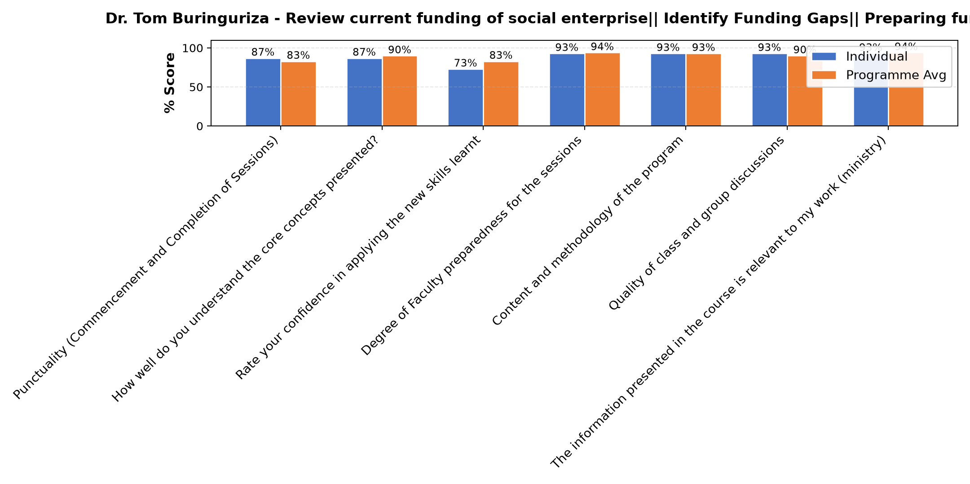

Comments & Feedback
- • I need to work hard to implement
- • When am not given chance
SUBMITTED THROUGH:
SBS Evaluation Automation System

